28th Annual Groton Tuff Tigers

Wrestling Tournament

Sunday, February 18th 2018

Following State AAU Rules |  | 4 Man Round Robin Where
Born In: |  | Possible
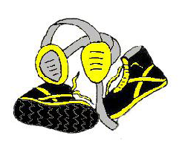  Tots: 2012 & After |  | All Trophy Tournament
Bantam: 2010 & 2011 |  | Wrestlers: $10.00
Midget: 2008 & 2009 |  | Adults: $7.00
Novice: 2006 & 2007 |  | Students: $3.00
Schoolboy: 2004 & 2005 |  | AAU Cards NOT Required

Check-In 9:00-10:00 NO WALK-INS - Will be bracketed the night before
We reserve the right to put any wrestler on the scale
Wrestling as close to 11:00 as Possible/Groton HS Arena

Fastest Pin Trophy in each division - Boys and Girls will be bracketed together

One Coach per Wrestler on Mat Side – Please keep all kids that are not wrestling off the sides of the mats and in the stands when not wrestling.
PRE REGISTRATION REQUIRED BY
Friday, February 16th at 5:00pm:
https://goo.gl/forms/wDK8yiaKLYoShQpt1
To check your registration, please see the following:
https://docs.google.com/spreadsheets/d/1ItbpfvtWYBAGV78GCOsFgGQ8-y3psOgu1XwZOxOGevU/edit?usp=sharing
For Questions or Concerns about our tournament, please contact any of the following:
Chad Johnson - 395.7711
Eric Moody - 397.7117
Julie Erdmann - 216.8141
Darin Zoellner - 661.1635
Jason Hill - 715.7156
Coach Pat Krause – 216.8091 and Coach Chris Kucker – 848.0267

